

We didn’t invert solar – we perfected it.

To Whom It May Concern:

I highly recommend Mari's Cleaning Service for your janitorial services. We have been using Mari's service for almost a year now and we will never switch! Mari and her staff are professional, conscientious, dependable, easy to work with and always on time. Their attention to detail is exceptional.

When looking to switch providers, I interviewed several companies that claimed to be the best. Mari by far had the best price and has been flexible with us when changes in service dates or other needs have come up.

We are ·not the easiest client for her to service; we've made many demands and had some last minute changes. Every time, Mari has been gracious and accommodating and they have my highest recommendation.

If you have any questions or concerns, please feel free to contact me at your convenience.

Sincerely,

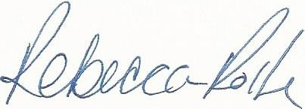

Rebecca Rolfe Office Manager

rrolfe@perfectpowersolar.com



20601 N. 19th Ave, Ste. 150, Phoenix, AZ 85027

P: 623.581.1700 F: 623.581.1710 www.perfectpowersolar.com

ROC#: K11 264981