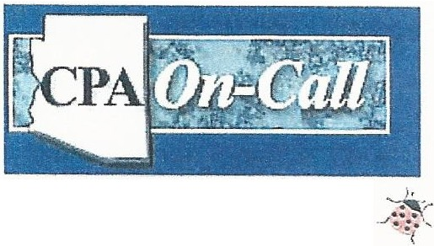
Carolyn A. Clark, CPA

Ladybug Resources, LLC.
www .cpaoncallAZ.com
carolynclark@cox,net

623.825.6590
9516 W. Peoria Avenue
Suite 1
Peoria, AZ 85345

FI N A N CIA , TAX , & ACCOU NTI N G SERVICE S

To Whom It May Concern:

We have been using M a r i ‘ s Cleaning Services for almost 7-months now and highly recommend them for your office or house cleaning.

I have nothing but the very best to say about Mari and her entire crew! Mari is very personable and was quite willing to speak with me at length regarding my special cleaning needs, and her crew far exceeded my needs and expectations.

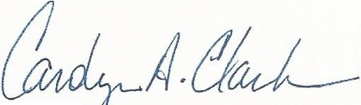
Honesty and trustworthiness is very important since we are providing a key to her staff. Mari explained to me how the keys are stored at the office and we. have .had no problem with the staff what so ever.

Carolyn A . Clark
Certified Public Accountant
9516 W. Peoria Ave Suite 1 Peoria, AZ 85345
Phone 623.825.6590

